**20MCA132:OBJECT ORIENTED PROGRAMMING LAB**

**TKM20MCA-2020**

**Program code:**

**package** trffic;

**import** java.io.FileReader;

**import** java.io.Writer;

**import** java.io.BufferedWriter;

**import** java.applet.Applet;

**import** java.awt.*;

**import** java.awt.event.*;

**import** java.awt.Graphics;

/*<applet code=Light.java width=500 height=500>

</applet> */

**public** **class** Light **extends** Applet **implements** ActionListener{

**private** **static** **final** Writer ***sc*** = **null**;

Button b1,b2,b3;

**public** **void** init(){

b1=**new** Button("G");

b2=**new** Button("Y");

b3=**new** Button("R");

b1.setBounds(220,150,50,50);

b2.setBounds(220,90,50,50);

b3.setBounds(220,30,50,50);

add(b1);

add(b2);

add(b3);

b1.addActionListener(**this**);

b2.addActionListener(**this**);

b3.addActionListener(**this**);

}

**public** **void** actionPerformed(ActionEvent ae){

**if**(ae.getSource()==b1)

{

**try**{

FileReader fr=**new** FileReader("F:\\MCA2\\trffic\\src\\trffic\\even.txt");

BufferedWriter br=**new** BufferedWriter(***sc***);

br.write("F:\\MCA2\\trffic\\src\\trffic\\even.txt");

fr.close();

}**catch**(Exception e){

System.***out***.println("Error");

}

}

**if**(ae.getSource()==b2)

{

**try**{

FileReader fr=**new** FileReader("F:\\MCA2\\trffic\\src\\trffic\\odd.txt");

BufferedWriter br=**new** BufferedWriter(***sc***);

br.write("F:\\MCA2\\trffic\\src\\trffic\\odd.txt");

fr.close();

}**catch**(Exception e){

System.***out***.println("Error");

}

}

**if**(ae.getSource()==b3)

{

**try**{

FileReader fr=**new** FileReader("F:\\MCA2\\trffic\\src\\trffic\\numbers.txt");

BufferedWriter br=**new** BufferedWriter(***sc***);

br.write("F:\\MCA2\\trffic\\src\\trffic\\numbers.txt");

fr.close();

}**catch**(Exception e){

System.***out***.println("Error");

}

}

repaint();

}

**public** **void** paint(Graphics g){

g.drawRect(150,40,170,200);

g.setColor(Color.***BLACK***);

g.fillRect(150,40,170,200);

g.setColor(Color.***RED***);

g.drawOval(220, 150, 50, 50);

g.fillOval(220, 150, 50, 50);

g.setColor(Color.***YELLOW***);

g.drawOval(220,90,50,50);

g.fillOval(220, 90, 50, 50);

g.setColor(Color.***GREEN***);

g.drawOval(220, 30, 50, 50);

g.fillOval(220, 30, 50, 50);

}

}

**Output:**

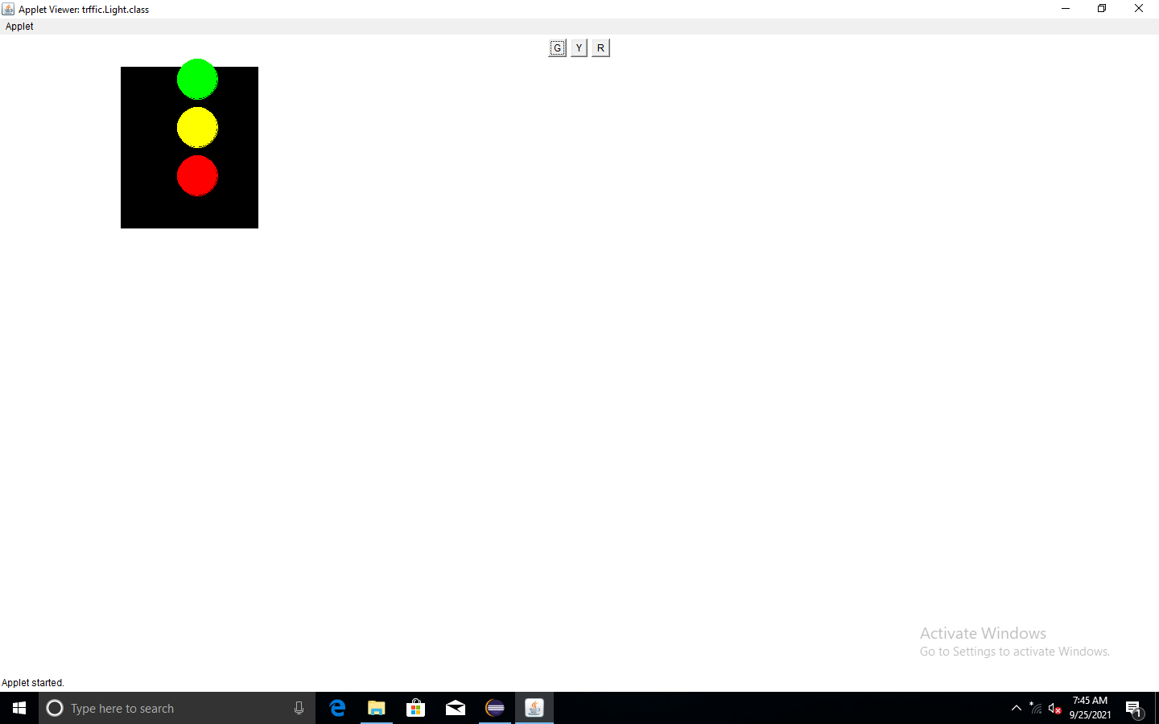

**GIT LINK**

<https://github.com/TKM-MCA-2020-OOPS-LAB/20MCA220-HELNA-E-M-OOPS-LAB/tree/main/EXTERNAL%20EXAM>